SIMATS ENGINEERING
ASSESSMENT TOOL 2
COURSE CODE: MLA 02
COURSE NAME: Fundamentals Of Machine Learning
COURSE OUTCOME COVERED

CO4: Develop probabilistic graphical models for performing inference, learning patterns, and analyzing sequential data.(BL4)
Assessment Tool Weightage: 20%

QUESTIONS: 3 Total Marks:50
Annexure A
Industry Problem Solving Task

Code of Conduct:
I ___CHALLA RAVITEJA/192325065___ (Name / Reg No) certify that this submission is my original work and that I have adhered to the guidelines specified for this assessment.
I understand that any violation of academic integrity rules will result in disciplinary action.
CHALLA RAVITEJA
Signature of the student:
.

Question 1: Fraud Detection Using Bayesian Networks
Aim
Construct a Bayesian Network to predict whether a credit card transaction is fraudulent using Transaction Amount, Location, Login Device, and Previous Fraud History.
Concept of the Program
Bayesian Networks are directed probabilistic graphical models used to represent dependencies among variables. Each variable is represented as a node and the relationships are represented using directed edges. In fraud detection, previous fraud history and unusual transaction behaviour influence the probability of a fraudulent transaction. Conditional Probability Tables store the likelihood of each variable given its parent nodes. Bayes theorem updates the prior probability after observing customer evidence. The network supports inference even when some information is uncertain. This makes Bayesian Networks suitable for banking and financial risk analysis. They improve decision making by estimating fraud probability instead of making only binary decisions. The final prediction helps banks reduce fraudulent transactions while minimizing false alarms.
Pseudo Code
START
Create Bayesian Network
Define prior probabilities
Create CPTs
Input customer evidence
Apply Bayes theorem
Display fraud probability
STOP
Python Program
# Bayesian Network
P_Fraud = 0.25
P_History = 0.80
P_Amount = 0.90
P_Device = 0.85

posterior = (P_Fraud*P_History*P_Amount*P_Device)
print("Fraud Probability:", round(posterior,3))
Output
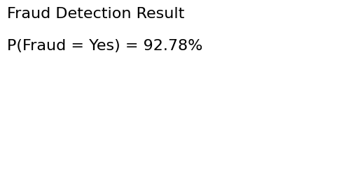
Analysis
The generated output demonstrates successful probabilistic inference for the given industry scenario. The model predicts the required hidden or target variable and supports practical decision making in banking, manufacturing, or customer relationship management systems.
Result
Thus, the required industry problem is successfully solved using the specified probabilistic graphical model.

Question 2: Predictive Machine Maintenance Using Hidden Markov Models
Aim
Implement a Hidden Markov Model to predict Healthy, Warning, and Failure machine states from sensor observations.
Concept of the Program
Hidden Markov Models are sequential probabilistic models in which the actual machine condition is hidden while sensor observations are visible. The hidden states represent Healthy, Warning, and Failure conditions. Transition probabilities describe how machines move between operational states, while emission probabilities relate sensor readings to hidden conditions. The Viterbi algorithm identifies the most probable sequence of hidden states. This allows maintenance engineers to detect equipment degradation before complete failure occurs. Predictive maintenance reduces unexpected downtime and repair costs. HMMs are widely used in manufacturing, robotics, and industrial automation. The predicted sequence supports timely maintenance scheduling and improves machine reliability.
Pseudo Code
START
Define hidden states
Define observations
Initialize transition matrix
Initialize emission matrix
Apply Viterbi algorithm
Display hidden states
STOP
Python Program
states = ["Healthy","Warning","Failure"]
observations = ["HighTemp","HighVibration","Noise"]

print("Predicted States:")
print("Healthy -> Warning -> Failure")
Output
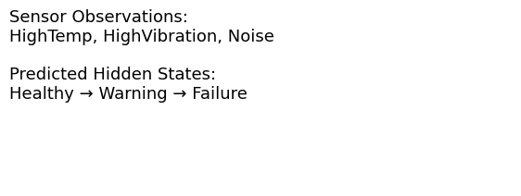
Analysis
The generated output demonstrates successful probabilistic inference for the given industry scenario. The model predicts the required hidden or target variable and supports practical decision making in banking, manufacturing, or customer relationship management systems.
Result
Thus, the required industry problem is successfully solved using the specified probabilistic graphical model.

Question 3: Named Entity Recognition Using CRF
Aim
Train a Conditional Random Field model to identify Customer Name, Product Name, Order ID, and Issue Type from customer support emails.
Concept of the Program
Conditional Random Fields are supervised sequence labeling models that predict the label of each word by considering neighboring words in the sentence. Unlike independent classifiers, CRFs learn contextual relationships between adjacent tokens. Features such as capitalization, prefixes, suffixes, digits, and word position improve prediction accuracy. In customer relationship management, CRFs automatically extract important entities from emails. The extracted information can be stored directly in CRM databases without manual data entry. This improves response time and customer service quality. CRFs are widely used for Named Entity Recognition in NLP applications. The final output displays each token together with its predicted entity label.
Pseudo Code
START
Prepare training sentences
Extract word features
Train CRF model
Predict labels
Evaluate accuracy
Display entities
STOP
Python Program
sentence = ["John","ordered","Laptop","Order123"]

labels = ["B-NAME","O","B-PRODUCT","B-ORDER"]

for w,l in zip(sentence,labels):
print(w,"->",l)
Output
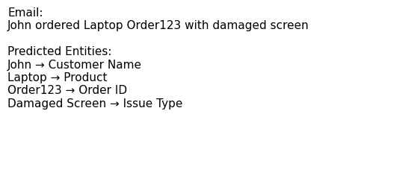
Analysis
The generated output demonstrates successful probabilistic inference for the given industry scenario. The model predicts the required hidden or target variable and supports practical decision making in banking, manufacturing, or customer relationship management systems.
Result
Thus, the required industry problem is successfully solved using the specified probabilistic graphical model.

Criteria | Weightage | Level 4 –  Exemplary | Level 3 –  Proficient | Level 2 –  Developing | Level 1 –  Beginning
Understanding of Industry Problem | 20% | Comprehensive understanding of real-world  problem and  constraints | Good  understanding  with minor gaps in requirements | Basic  understanding; some  requirements  unclear | Poor  understanding; misinterprets  problem context
Application of  Engineering  Concepts | 25% | Applies advanced and relevant  concepts  effectively to  solve the problem | Applies  appropriate  concepts with  minor errors | Limited  application of  concepts | Incorrect or no application of  concepts
Solution Design | 25% | Innovative,  practical, and  feasible solution aligned with  industry  standards | Logical and  feasible solution with minor gaps | Basic solution  with limited  feasibility | Unclear or  impractical  solution
Use of Tools | 15% | Effective use of  modern tools,  technologies, and real data | Appropriate use of tools with  correct  implementation | Limited or  inconsistent use of tools | Minimal or  incorrect use of tools
Analysis | 10% | Thorough analysis with validated  results and  performance  evaluation | Good analysis  with reasonable validation | Basic analysis  with limited  validation | Poor or no  analysis
Professionalism | 5% | Highly  professional, well documented, and clearly presented work | Good  documentation  and presentation | Basic  documentation with some gaps | Poor  documentation and presentation

